AUTH-022
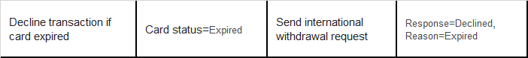
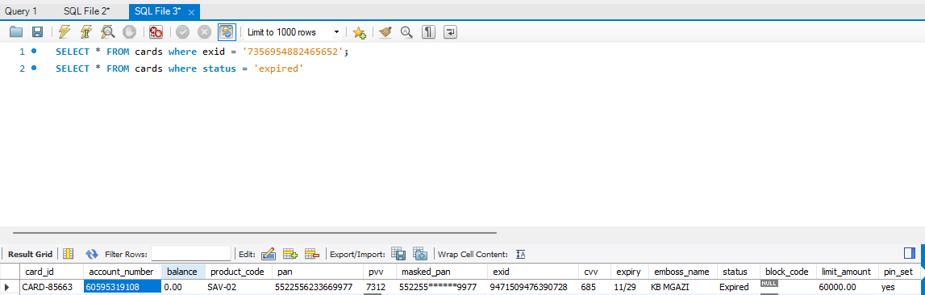
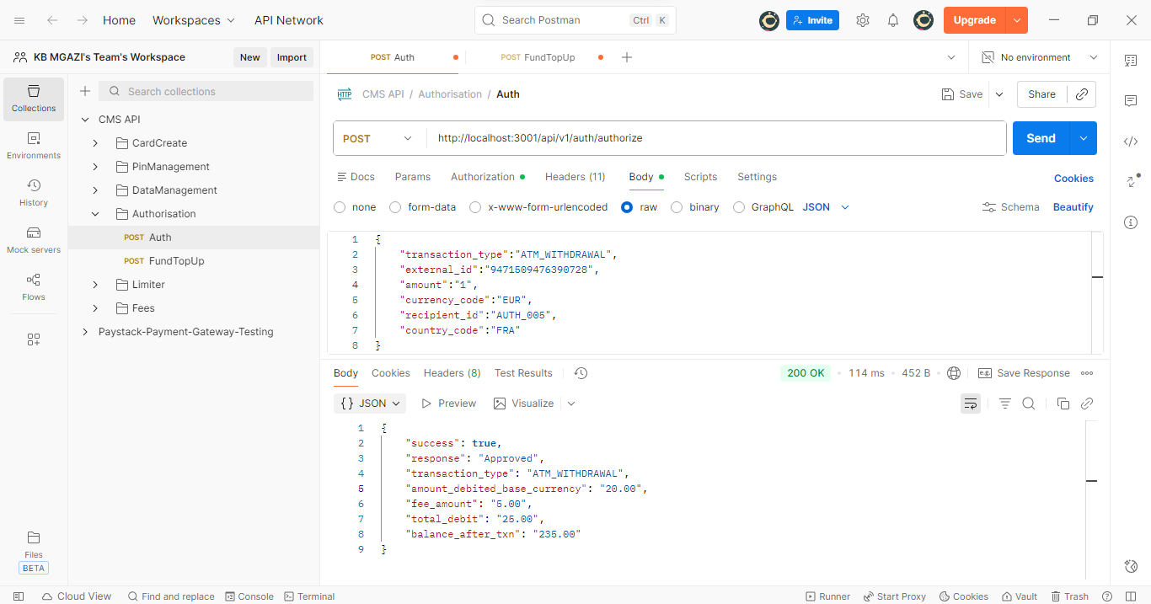
Request:
{
"transaction_type":"ATM_WITHDRAWAL",
"external_id":"9471509476390728",
"amount":"1",
"currency_code":"EUR",
"recipient_id":"AUTH_005",
"country_code":"FRA"
}
Response:
{
"success": true,
"response": "Approved",
"transaction_type": "ATM_WITHDRAWAL",
"amount_debited_base_currency": "20.00",
"fee_amount": "5.00",
"total_debit": "25.00",
"balance_after_txn": "235.00"
}

